SonarQube

Introduction:

SonarQube is an open-source platform which is used to inspect the code quality. It provides a detailed report of the code to perform automatic reviews with static analysis of code to detect bugs.

Prerequisites:

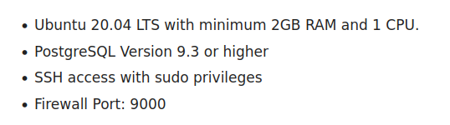

Setting up Ubuntu OS

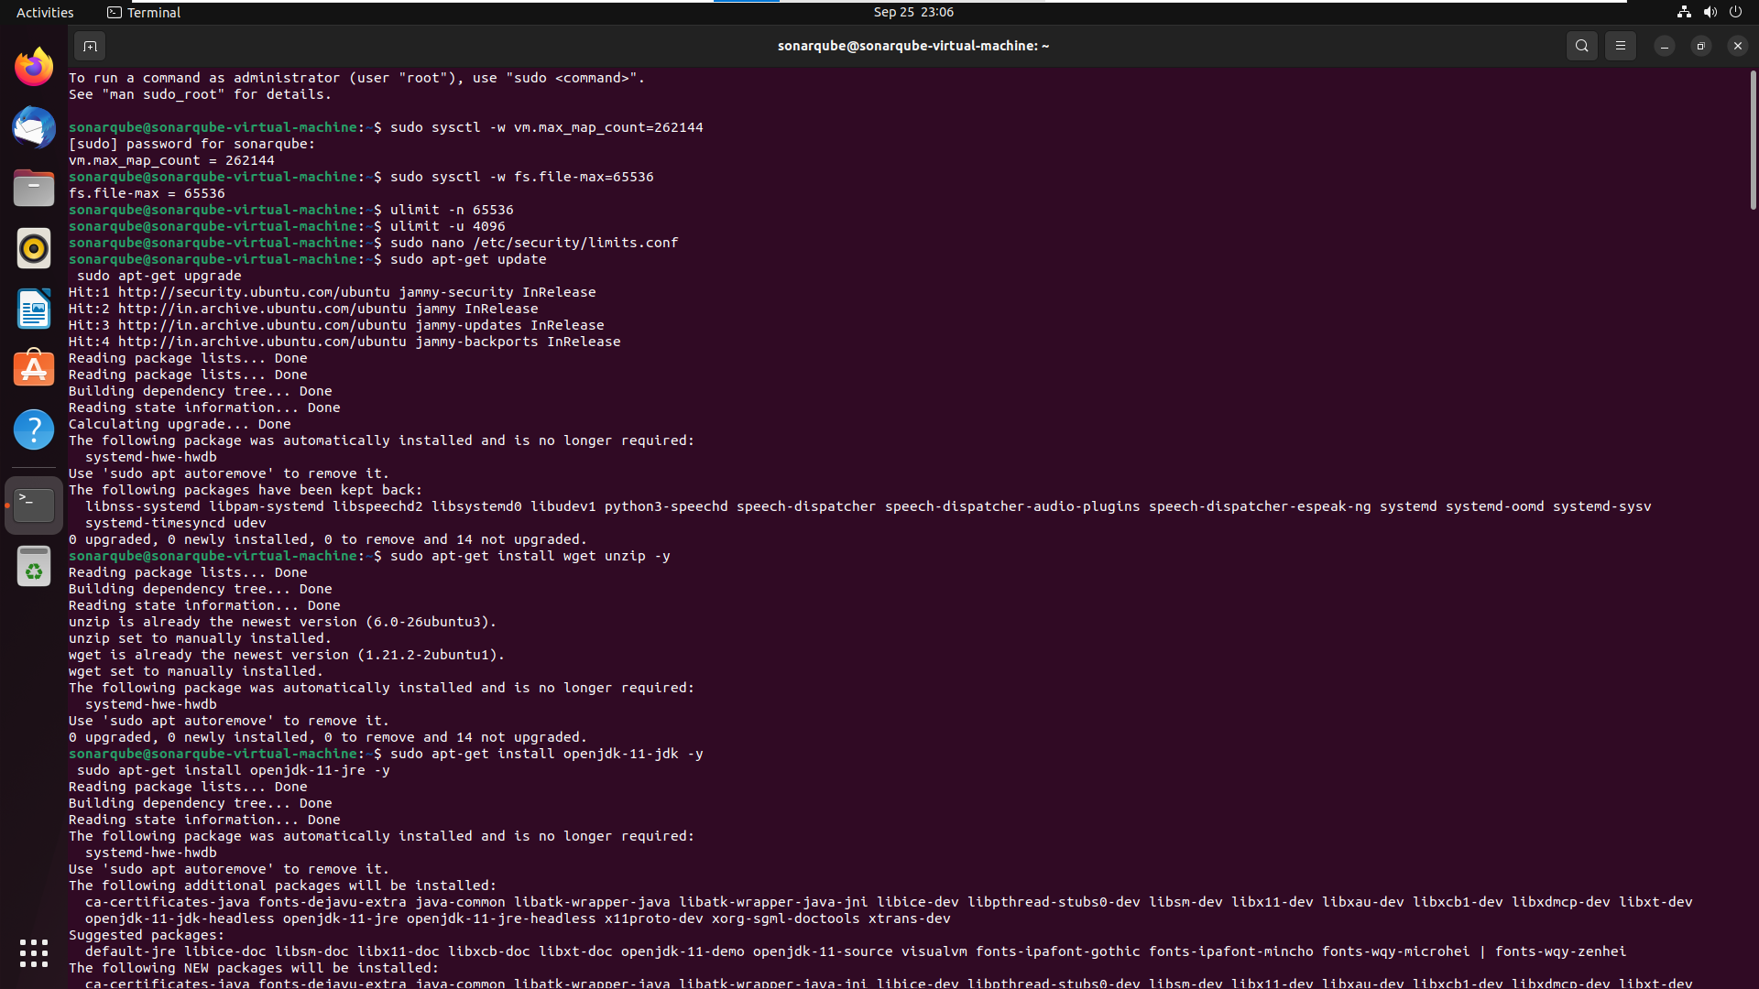

Installing openjdk-11:



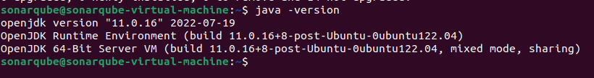

Downloading Postgresql Package and installing :

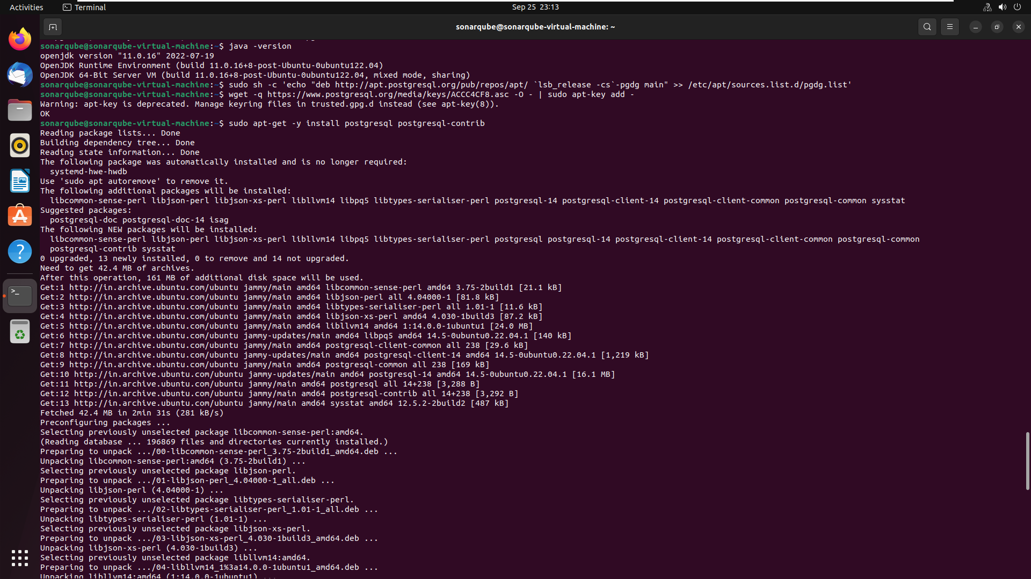

Starting and enabling Postgresql service

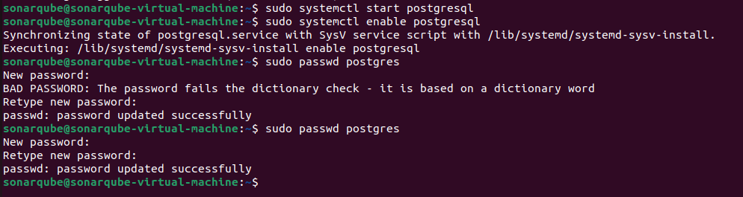

Creating user in postgresql and creating a database:

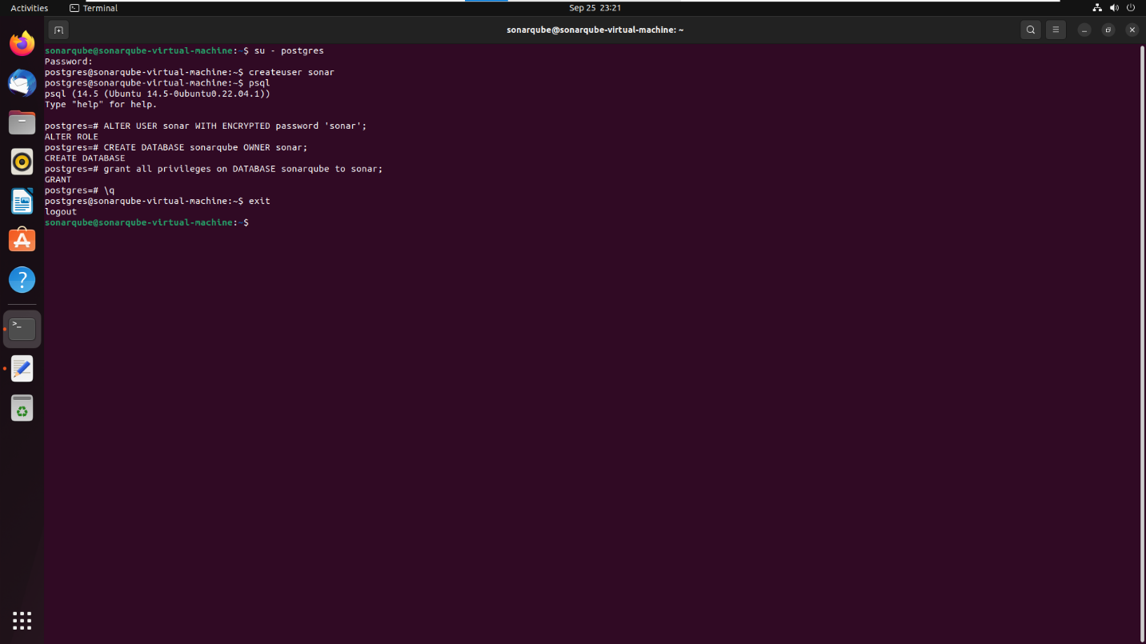

Downloading the lastest version of SonarQube and unzipping it into “opt/sonarqube/”

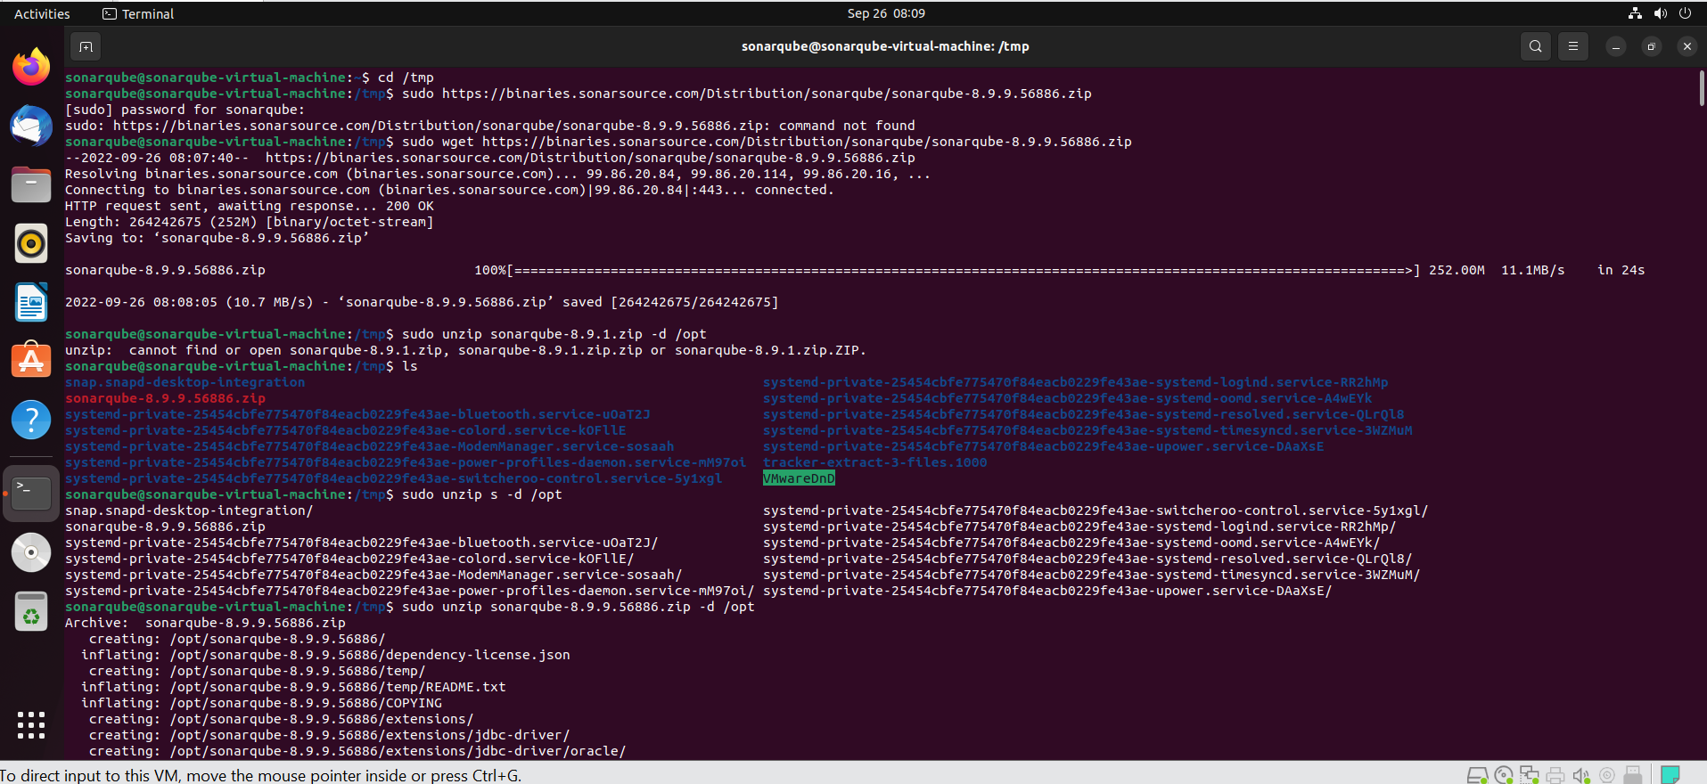

Creating another user names “sonar” and granting that user the permissions to the sonarqube directory:

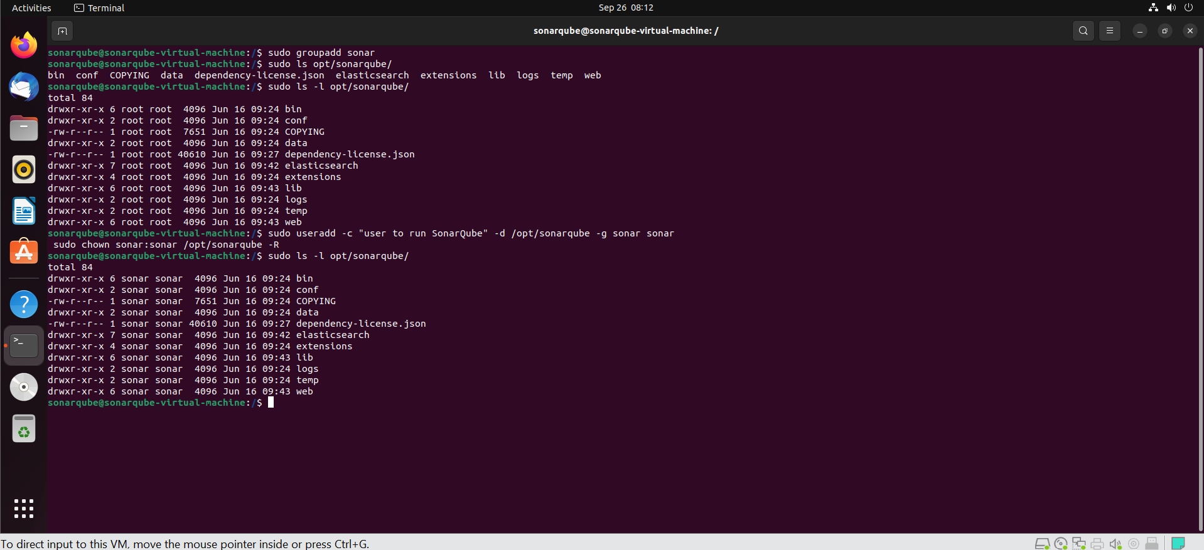

Configuring sonar.properties file to access the database:

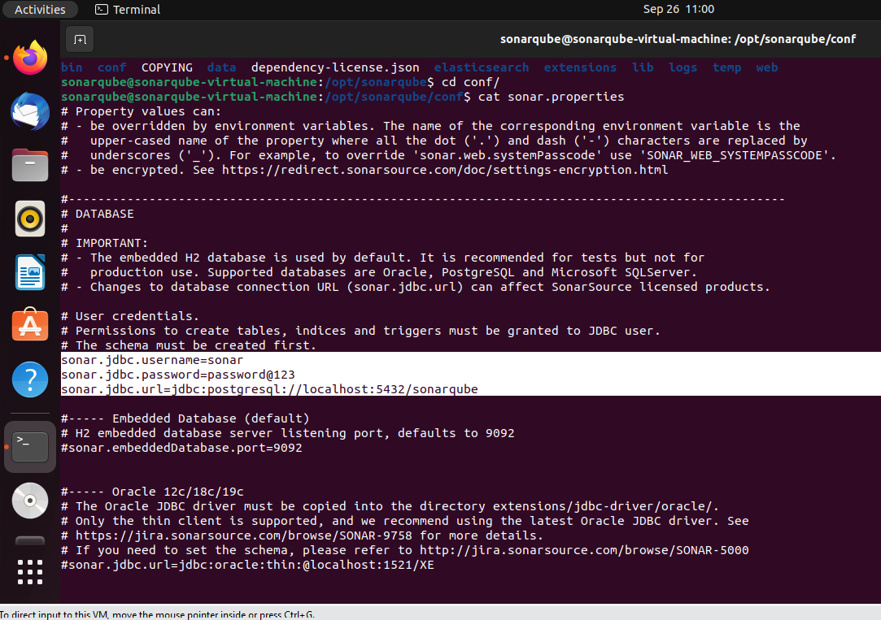

Configuring the sonar.sh file and setting the RUN_AS_USER to sonar:

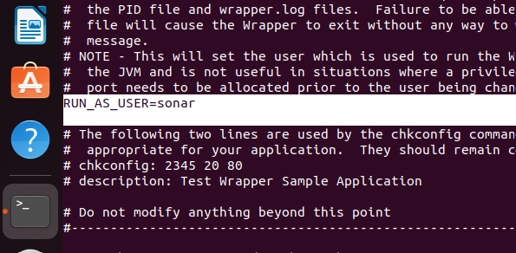

Logging into sonar user:

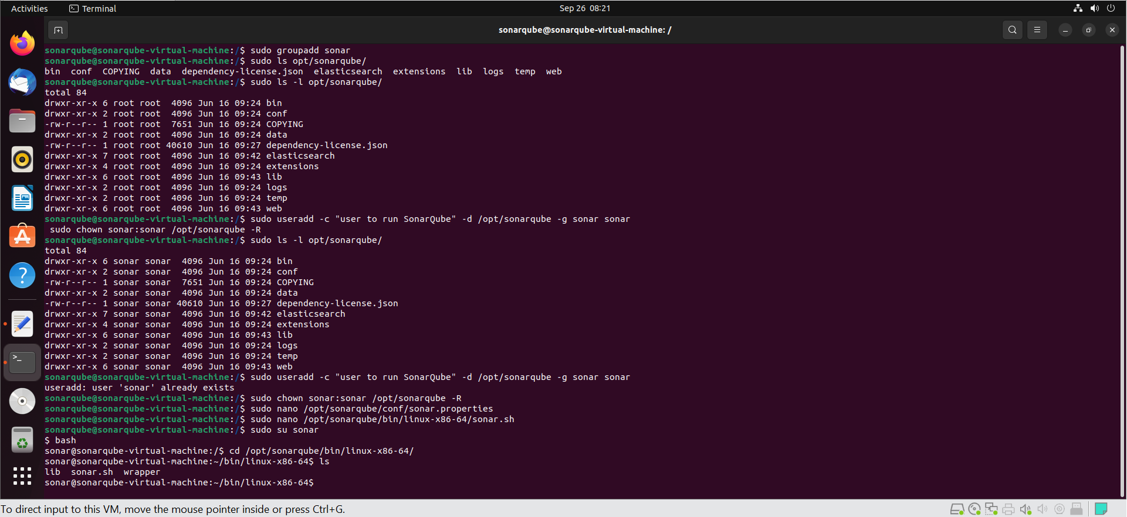

Manually starting the sonar.sh:

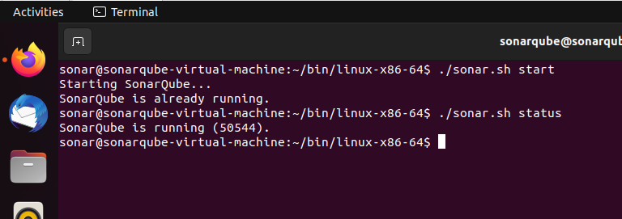

Create sonar.service file in “sudo nano /etc/systemd/system/sonar.service” directory:

And enter the following:

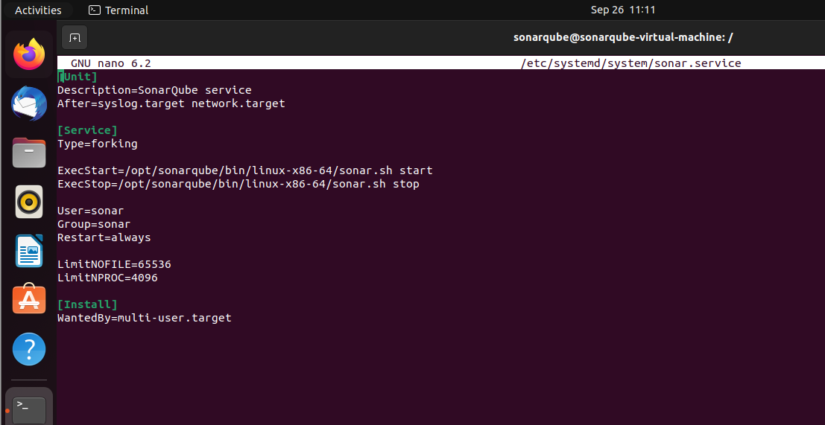

We will now be able to run SonarQube using the Systemctl command instead of navigating to bin directory

